**Task 1 – Chat GPT**

**Definition of CSS:**

**CSS (Cascading Style Sheets)** is a stylesheet language used to describe the presentation of a document written in HTML or XML. It allows web developers to separate content (HTML) from design (CSS), giving flexibility to style web pages without changing the underlying structure. CSS controls the layout, colors, fonts, spacing, and other visual elements of a web page.

### Role of CSS in Web Development:

* **Separation of Content and Style:** CSS separates how a page looks from its HTML structure, making it easier to manage large websites.
* **Consistency:** CSS allows web developers to apply styles across multiple pages, ensuring a consistent look and feel.
* **Efficiency:** Using CSS reduces the need to repeat styling in every HTML element, saving time and effort.
* **Responsiveness:** CSS helps create responsive designs that adjust to different screen sizes and devices.

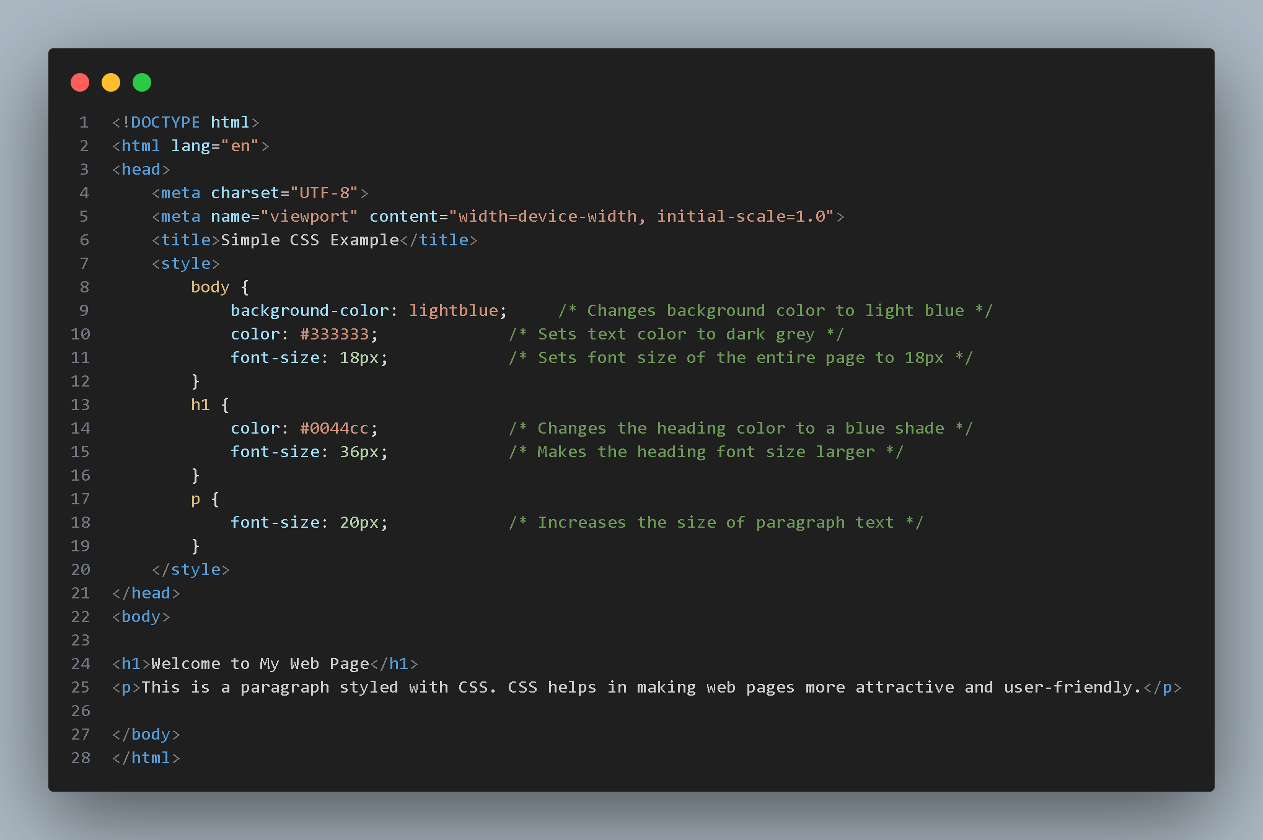

### Explanation of the CSS Code:

1. **Body Selector:**
   * **background-color: #f0f8ff;**: This sets the background color of the entire web page to a light blue shade (#f0f8ff is the color code for AliceBlue).
   * **color: #333333;**: This sets the default text color of the entire page to dark grey.
   * **font-size: 18px;**: This sets the default font size for all text on the page to 18 pixels.
2. **h1 Selector:**
   * **color: #0044cc;**: This changes the text color of the <h1> heading to a specific blue shade.
   * **font-size: 36px;**: This makes the font size of the <h1> element 36 pixels, making it larger and more prominent.
3. **p Selector:**
   * **font-size: 20px;**: This increases the font size of the paragraph text to 20 pixels, making it slightly larger than the default text size for easier readability.

### Effect of the CSS on the HTML Elements:

* **Background Color:** The entire page's background becomes light blue (#f0f8ff), affecting the user’s visual experience and making the text stand out.
* **Text Color:** The text color of the page, including the paragraph and headings, is styled separately. The body text is dark grey (#333333), while the heading text is a distinctive blue (#0044cc).
* **Font Size:** The text sizes are controlled by CSS, with the body font size set to 18px, the paragraph text at 20px, and the heading larger at 36px for clear hierarchy and readability.

**Result :**

